Scalawag
Reckoning with the South
POSTED INRACE & PLACE

Without profit from stolen Indigenous lands, UNC would have gone broke 100 years ago
by LUCAS P. KELLEY & GARRETT W. WRIGHT September 15, 2020

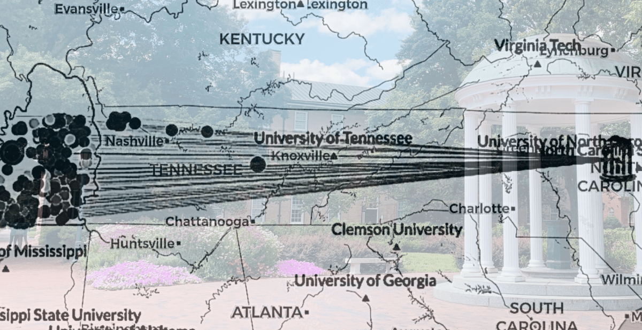

Stolen Indigenous land built universities across the United States.
In March, High Country News published a groundbreaking study by Robert Lee and Tristan Ahtone titled "Land-Grab Universities," describing how 52 U.S. universities owe their existence to the seizure and sale of over 10 million acres of Indigenous land through the Morrill Act of 1862, signed by U.S. President Abraham Lincoln, which granted federally controlled land to the states for them to sell in order to fund educational institutions.
So-called land-grant universities are in reality "land-theft" institutions. They are also examples of only one of the ways in which American institutions of higher education have profited from Native dispossession. But other universities—including many across the South—have an earlier, hidden history of stealing Indigenous land from the very moment of their creation.
A map identifies over 200,000 acres of Cherokee and Chickasaw lands expropriated by The University of North Carolina at Chapel Hill (UNC) with the aid of federal treaties and policies of Indigenous removal. From 1818 to 1840, land sales comprised on average 34.6 percent of UNC's annual budget. The authors identified 17 other universities in the South supported by the seizure and sale of Indigenous lands, including 12 land-grant institutions through the Morrill Act of 1862, and five universities funded by Indigenous lands in a similar manner to UNC. Map created by Adrienne Hall.
In our own research, we found many universities across the South were funded in their early years through the sale of land gained through treaties with various Native nations. The University of North Carolina, for example, invested heavily in Cherokee and Chickasaw land hundreds of miles away in what is now western Tennessee.
Beginning in 1789, when UNC was chartered and awarded thousands of acres of western lands by state legislators, UNC claimed large swaths of land within the boundaries of these Native nations. But for years, UNC struggled financially and could not profit off of this Indigenous land due to Cherokees' and Chickasaws' forceful assertions of territorial sovereignty.
"This treaty is very important to a great Many Claimants under North Carolina. The University will be made rich by it."
Indeed, UNC operated at a loss nearly every year from 1789 to 1818, as Native leaders worked tirelessly to protect their homelands from U.S. expansion. Whereas UNC administrators claimed these western lands as university property, the Cherokees and Chickasaws who actually lived there rejected such claims.
One Cherokee man named Kenneteag (Little Turkey) explained to North Carolina officials in 1786 that his people's land "was our own right and property" and "the chief of our independence." From the founding of the U.S. through the 1810s, Cherokees and Chickasaws convinced the country to recognize their territorial sovereignty over much of the Tennessee and Cumberland valleys—making UNC's claims to this land meaningless.
All that changed when an 1818 treaty called The Great Chickasaw Cession formalized the seizure of all Chickasaw territory remaining in Tennessee. UNC officials were delighted by this treaty, as they saw it as a golden opportunity for the university to bounce back financially. "This treaty is very important to a great Many Claimants under North Carolina," rejoiced Trustee Archibald Murphey upon hearing of the 1818 cession. "The University will be made rich by it."
Murphey's words proved prophetic, as UNC only survived the financial upheavals of the early 19th century—including multiple panics and national depressions—because they sold Cherokee and Chickasaw land.
In 1830—the same year that President Andrew Jackson signed the Indian Removal Act into law—UNC trustees funded nearly half UNC's budget (49.3 percent) by selling land that had once been owned by the Chickasaw Nation.
From 1818 to 1840, land sales comprised on average 34.6 percent of UNC's annual budget. This peaked in the fiscal year of 1834-1835, when 94 percent of the university's budget ($108,923.98—over $3 million in 2020 when adjusted for inflation) came from such land sales. Dispossession thus helped fund the creation of two new professorships and, alongside the exploitation of enslaved laborers, the construction or expansion of three buildings on campus—Gerrard Hall, Old West, and a third floor expansion on Old East.
In 1830—the same year that President Andrew Jackson signed the Indian Removal Act into law—UNC trustees funded nearly half UNC's budget (49.3 percent) by selling land that had once been owned by the Chickasaw Nation. Understanding the centrality of these sales within the university's history highlights the many ways in which American institutions have profited—and continue to profit—from the dispossession of the people who first lived here.
UNC is far from the only Southern public university to reap financial benefits from the dispossession of Native peoples. In addition to the 12 Southern institutions that received funding as land grant schools, we identified at least five other universities across the South—the University of Alabama, Florida State University, the University of Louisville, the University of Mississippi, and the University of Texas—that were funded through the seizure and sale of Native land in ways that are remarkably similar to UNC's history.
As universities across the country reckon with their institutions' long history of white supremacy in all regards, it is imperative that they further investigate into the unrecognized ways that institutions of higher education thrived as Native peoples lost their lands.
UNC has certainly not acknowledged this history. Despite the university's fetishizing of Native students as UNC's "brave firsts," only 116 American Indians enrolled at UNC-Chapel Hill in the fall 2019, with only 2,065 enrolled throughout the UNC system's 16 public universities. We hope that university administrators will work to increase the enrollment of Native students and the employment of Native scholars, as well as support North Carolina's large Native community, given the institution's long benefit from Native dispossession.
Universities' response to the COVID-19 pandemic has further exposed the broken model of U.S. higher education. As state legislatures continue to slash funding to public institutions, university administrators have become increasingly reliant on tuition dollars and private investment: the business model of higher education. Students in the University of North Carolina System have experienced this broken system firsthand over the past weeks.
Members of the board of trustees ignored public health guidelines and opened system campuses for in-person instruction in order to recoup student fees and tuition dollars despite the high risk to students, faculty, and campus workers. The surging COVID-19 cases among NC State and UNC students has been just one of the consequences.
Yet, as the history of UNC's financial benefits from Native dispossession demonstrates, institutions of higher education have been investing in and profiting off of harmful practices and products for centuries. In the 19th century, instead of health risks to students, the result was the dispossession of thousands of Native people in the southeast. Who will bear the cost of higher education's failures in the 21st century?

LUCAS P. KELLEY & GARRETT W. WRIGHT
Lucas Kelley is a PhD candidate at The University of North Carolina at Chapel
Hill currently completing a dissertation on American speculation and Native sovereignty in the Tennessee and Cumberland River Valleys in the late 18th and early 19th centuries and has explored UNC's investment in Cherokee and Chickasaw dispossession. Primarily a historian of the Great Plains, Dr. Garrett Wright has conducted extensive archaeological and archival research on Indigenous histories of The University of North Carolina at Chapel Hill as a research assistant for the UNC Historical Task Force.

