Appeared in The Warren Record on March 20, 2019

WCHS senior earns Morehead-Cain Scholarship
- By Luci Weldon
- Mar 20, 2019 Updated May 1, 2019

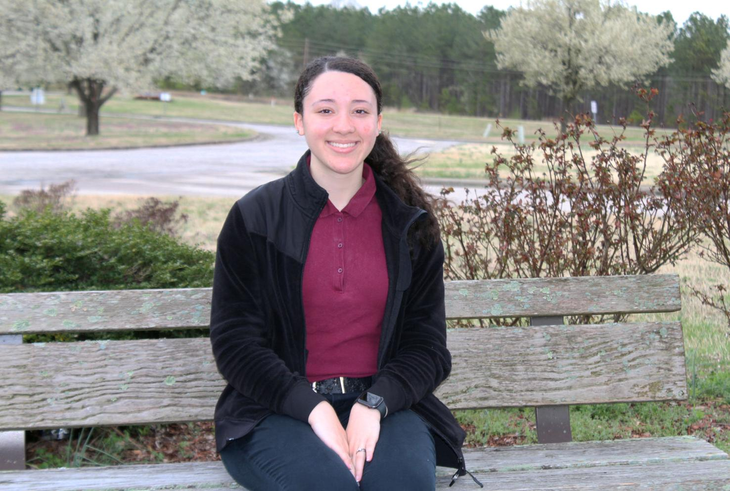

Warren County High School senior Zianne Richardson has become the fourth Warren County student to receive the prestigious Morehead-Cain Scholarship, which pays all expenses for four years of undergraduate study at the University of North Carolina at Chapel Hill. In addition, she will receive a laptop computer and have the opportunity to participate in four summer enrichment programs.
Richardson, the daughter of Garland Arnold Richardson and Ladonna Richardson, and Ivan Richardson, all of Hollister, has developed a reputation for working to make a difference in her community. She serves as Miss Haliwa-Saponi Indian Princess with a platform of “Be Your Best Self” and is the WCHS student body secretary. Zianne was class president in her junior year and has mentored freshmen, preparing them for the transition to the high school environment, and volunteered with Special Olympics. Even while juggling so many responsibilities, she maintains a strong academic record as a member of the National Honor Society.
Zianne describes herself as someone who wants to enter every situation with a plan of what needs to be done. Thinking about a future career was no exception. Zianne wanted to plan her future — in middle school. She thought she wanted to attend the University of North Carolina at Pembroke to obtain a degree in Elementary Education before becoming a teacher just like her role model, her fifth-grade teacher, Tammy Evans.
In high school, she became more involved with programs at UNC. She participated in Carolina Horizons through the university’s American Indian Center, which focused on preparing students for college. There, she formed a strong connection with UNC’s Native American community.
Last year, she participated in Project Uplift, which provided more in-depth instruction in preparing for college with a focus on minority populations living in rural communities. There, Zianne was challenged to learn more about herself through self-reflection activities. She also had an opportunity to explore other minority cultures and various campus groups at UNC.
At Carolina Horizons, she learned about the Morehead-Cain Scholarship and thought she should apply. True to form, Zianne made what she termed a road to college textbook with everything she would need for college applications, complete with due dates and sample essay prompts. She was making plans to complete a Morehead-Cain application on her own when she learned that WCHS guidance counselor Tannis Jenkins had nominated her for the prestigious honor.
Zianne still had to complete the application form, which covered topics ranging from academics to community service. She responded to several short answer and essay questions, including one that challenged her to think of something she regretted and to consider what she would do differently in a similar situation. Zianne wrote about two pages. The application was not as daunting as she had feared.
In the middle of December, Zianne learned that she was one of a few hundred students selected as semi-finalists out of 2,000 applicants. Zianne traveled to the UNC-Chapel Hill campus for interviews this winter. She described the atmosphere among the scholarship semi-finalists and panelists who would conduct the interviews as welcoming and accommodating. Zianne was not nervous at all.
The interview process first included a role-playing scenario. Students were placed in small groups and acted out a role of what their “character” might do in a hypothetical situation.
Afterward, they participated in panel interviews. Zianne said that she was expecting to be asked generalized questions about her community activities. Instead, panelists asked about duties as Miss Haliwa-Saponi Indian Princess and her platform. Zianne was excited to talk about her passion of encouraging others to succeed.
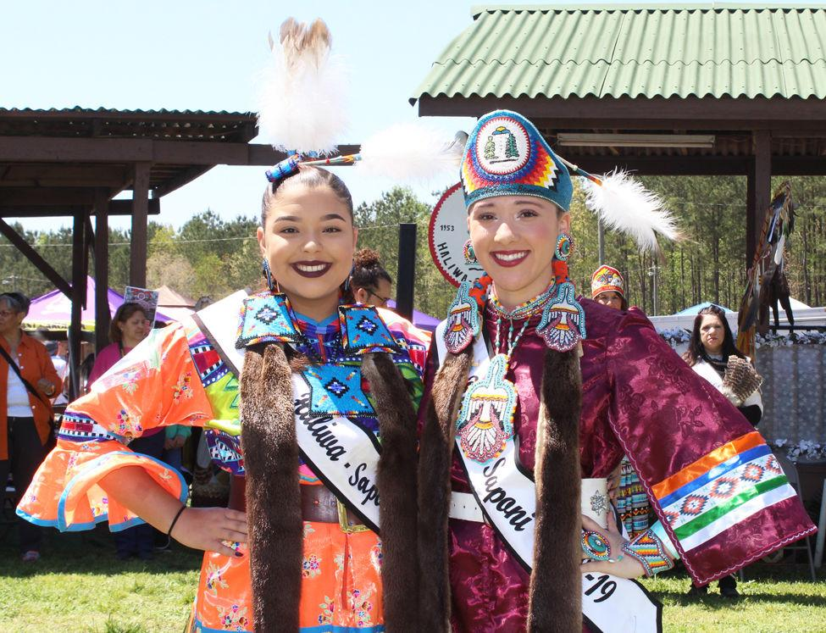
In this 2018 file photo, Zianne Richardson, right, is crowned Miss Haliwa-Saponi Indian Princess 2018-19 during the Haliwa-Saponi Tribe’s annual Powwow. She is pictured with Selena Raquel Lynch, Miss Haliwa-Saponi Indian Princess 2017-18.

Early this year, she learned that she was chosen to participate in finals weekend, which coincided with the weekend of the Carolina Indian Circle Powwow. Once again, Zianne juggled responsibilities representing the Haliwa-Saponi Tribe at the Powwow and completing activities related to the Morehead-Cain Scholarship.
Morehead-Cain finalists were paired with a current Morehead-Cain scholar and with several finalists, forming a scholar host team. They had an opportunity to explore the UNC campus and observe classes. Zianne attended a Social Justice and Education class with a professor she described as really cool. The professor incorporated personal experiences into his topic of discussion and gave Zianne materials related to the day’s assignment, making her feel like a college student.
Later, when it was time for her final scholarship interviews, she felt more at ease than she did at semifinal interviews, when she didn’t know what to expect. Zianne could show more of her personality in the hypothetical situations challenging students to consider what they would do, and she found that the panel interviews were much like the ones she experienced earlier.
While at UNC, Zianne met finalists from around the country and the world — China, Africa, England, Canada and South America.
“I had never met people from outside the country,” she said. “It opened my eyes to know how big the world was.”
Of 140 finalists, only 70 would receive the coveted Morehead-Cain Scholarship. Zianne knew that notification about the scholarship recipients would be made online around 5 p.m. on March 8, when she was still on the UNC campus.
Zianne, her mother, sister and friends were in a nearby hotel as 5 p.m. approached. The group waited patiently for the announcement, and finally, it came.
“I was in shock,” Zianne said. “We all started screaming.”
The screaming was so loud that people in the hotel’s hallway wanted to know if someone had been attacked or hurt.
When everyone calmed down, Zianne said the realization could set in. If she had not received the scholarship, she had a backup plan. Zianne previously received a merit scholarship for UNC that would have covered everything except books. However, with the Morehead-Cain Scholarship, she and her family will not have to worry about college funds, and she will participate in summer programs allowing her to travel to another area of the United States and another country. Zianne will do what she loves to do most: help make a difference. One summer, she will complete an internship related to her degree, most likely with a UNC graduate who completed the Morehead-Cain program.
Zianne has not graduated from high school yet, but the Morehead-Cain Scholarship has already played a role in allowing her to meet several dignitaries. On the UNC campus, she began talking with people she did not recognize. One of them in particular seemed to be excited that she would be attending the university as a Morehead-Cain Scholar. Afterward, Zianne was approached by someone from the campus newspaper, The Daily Tar Heel, who told her she had been speaking with Kevin M. Guskiewicz, interim chancellor.
She also had an opportunity to see Gov. Roy Cooper, whom she learned was a Morehead-Cain alumnus. Zianne just wanted to shake his hand, but Cooper gave her a fist bump, saying that the Morehead-Cain Scholarship changed his life.
When Zianne returned to WCHS, she was greeted by special visitors at the cafeteria last week. Morehead-Cain alumnus and county attorney Hassan Kingsberry, and Warren County Schools’ Student Success Coordinator and Morehead-Cain alumna Cathy Alston-Kearney, greeted her with flowers and balloons. In addition to Richardson and Kingsberry, other Warren County Morehead-Cain alumni are William W. Taylor III and Ali Tharrington.
Always the planner, Zianne has mapped out her collegiate career. She plans to major in Human Development and Family Studies, which would provide her with multiple career options from teaching to working as a school guidance counselor. Zianne plans to double minor in American Indian Studies and Performing Arts.
In her sophomore year, she will be able to apply for the Master of Arts degree in Teaching, which will allow her to begin master’s degree-level courses as an undergraduate and earn her master’s degree one year after receiving her Bachelor of Arts degree.
Zianne plans to return to her home community after graduating. She would like to teach at Vaughan Elementary School and eventually become the youth services coordinator with the Haliwa-Saponi Tribe. Zianne wants to raise her family in the same community she grew up in so that they will grow up appreciating the Haliwa-Saponi culture and experiencing the feeling of a close-knit community.
Most of all, she wants to continue making a difference. Zianne was disappointed that she was the only Native American among the Morehead-Cain finalists. She wondered if they were unfamiliar with the scholarship or educational opportunities that are available or did not believe they could achieve such a goal.
However, Zianne wants to do something about that. She would like to show Native American youth, students from rural areas — and everyone she meets — that a college education and the Morehead Scholarship are well within their reach if they apply themselves. With Zianne’s characteristic determination, she will do just that.

