Appeared in The Daily Tarheel on March 7, 2022

Carolina Indian Circle holds first in-person powwow since pandemic
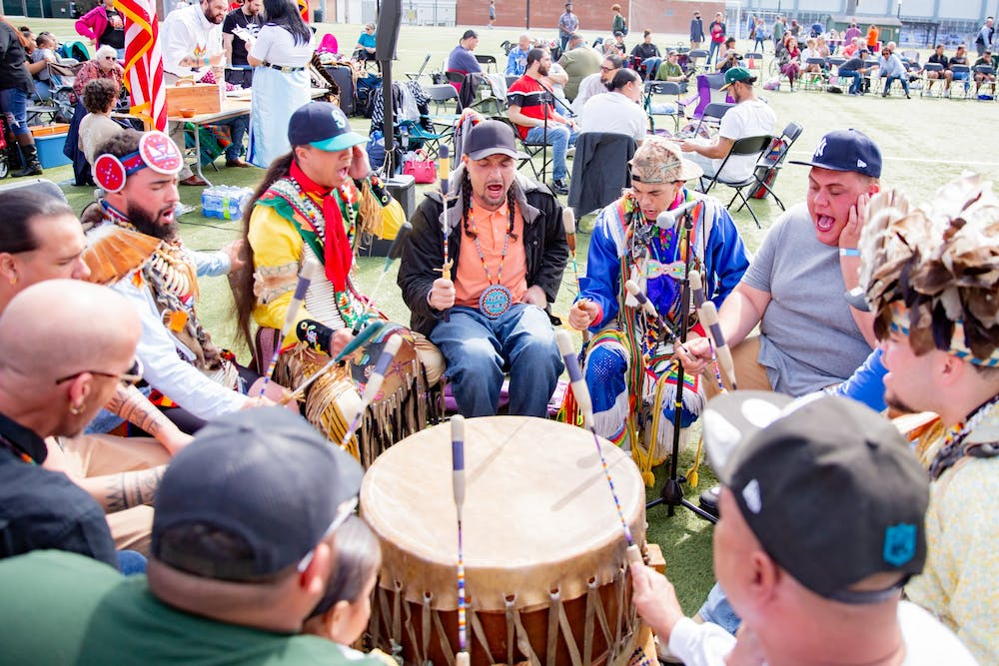
Buy PhotosPhoto by Helen McGinnis | The Daily Tar HeelWar Paint performs at the CIC's 35th Annual Powwow at Hooker fields on March 5, 2022.
By Adele Morris
March 7, 2022 | 6:49pm EST
The beat of drums and the chimes of Native American jingle skirts created an atmosphere of anticipation on Hooker Fields last Saturday. Brightly patterned clothing passed by in flashes as Carolina Indian Circle members raced to finish registering dancers, and vendors of Native American jewelry, art and clothing laid out their inventory.
The air pulsed with excitement as people eagerly awaited the powwow’s start. When the clock struck 12 and dancers entered the performance area, the event was officially underway.
This year marked the CIC’s 35th annual powwow, one of the largest collegiate powwows on the East Coast. A powwow is a celebration of Native American culture featuring performances of dancing, singing and drumming.
This year’s celebration was the CIC’s first in-person powwow since the pandemic began in 2020.
“It’s just so many different moving parts with a powwow, and that’s what I love about it because you can literally be talking to a family member over here and then go over here and dance to your contest song," junior Zianne Richardson, vice president of the CIC, said. "Then go over here back to a food vendor and get something to eat, and then come back and just watch other people’s competitions and exhibition dances."

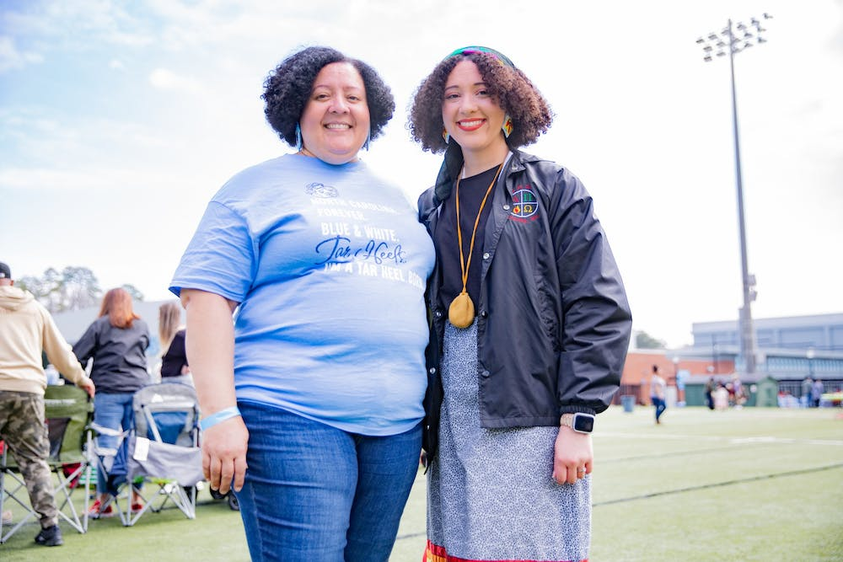
Helen McGinnis
Junior human development and family studies major and Vice President of the CIC Zianne Richardson smiles with her mother Ladonna Richardson '94 at the CIC's 35th Annual Powwow at Hooker fields on March 5, 2022.

The powwow involved six different types of dances: Men’s Grass, Men’s Fancy, Men’s Traditional, and Women’s Jingle, Women’s Fancy and Women’s Traditional.
Dancers of all ages were welcome to participate and had the option to compete in an individual dance style within their age group.
Both Richardson and her younger sister, first-year Evynn Richardson, CIC's culture co-chairperson, compared the powwow to a family reunion. The Richardsons are members of the Haliwa-Saponi Tribe and hold relations with the Nansemond Tribe of Virginia.
“It’s kind of like having a family reunion where you’re just coming back to this common space that you only see annually," Evynn Richardson said. "And then you see all this family, friends, and you just feel all the love, and knowing that stuff like this never changes."
When it occurs every year, the powwow unifies CIC members and other Native Americans in North Carolina and beyond — but the Richardson sisters and other CIC members said they wish for greater recognition from the University year-round.
“Words on Carolina’s campus aren’t worth much to us because they’re putting no action with it,” Evynn Richardson said. “I really want to see UNC show up and show out for Native students. Whether that’s funding the AIC more, helping us out more, coming to our events. Just showing up and showing out and actually putting some action behind those words.”
Though an official land acknowledgment from the University is still being developed, Zianne and Evynn Richardson said they feel like a land acknowledgment is simply not enough.
“We’re currently on Occaneechi Band of Saponi land,” Zianne Richardson said. “Nobody even knows the tribe’s land that we are currently standing on right now. And I think that’s one of the main issues when it comes to the University. People walk these bricks every day and don’t even know what they’re walking on.”
Mason Locklear, powwow co-chairperson and member of the Lumbee Tribe, and Tiana Jacobs, CIC’s recruitment and retention executive member and member of the Lumbee Tribe, both described what their Native identity means to them with the same word: "resiliency."

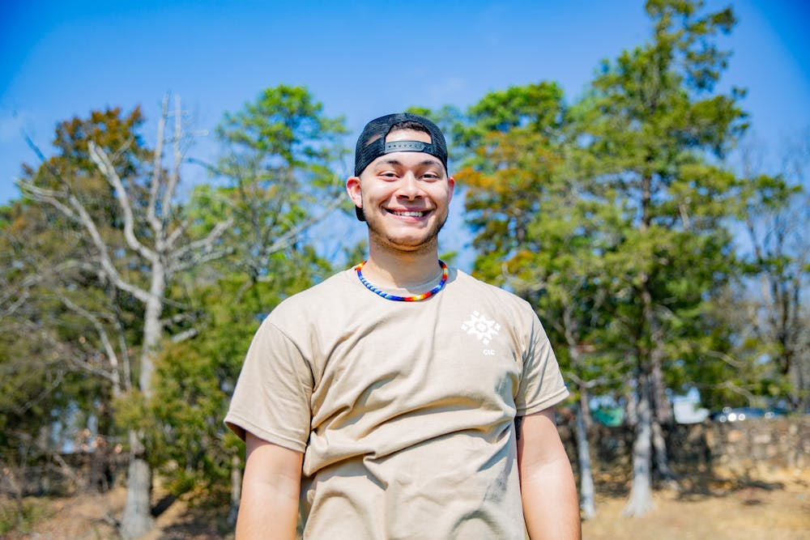
Helen McGinnis
Junior sociology major and member of the Lumbee Tribe Mason Locklear smiles for a portrait at the CIC's 35th Annual Powwow at Hooker fields on March 5, 2022.

They said, especially at a predominately white institution, having a Native American identity often means fighting to have their voices heard.
The powwow, Locklear said, is an important way of connecting with Native and non-Native community members each year.
“This powwow, to me, honestly means that I’m able to bring my culture and share my culture with everybody here on campus, especially at a PWI, just being able to teach people about who we are as people,” Locklear said.
Similarly, for Zianne Richardson, seeing the unity among attendees at the first in-person powwow since the pandemic was powerful.
“When I have on my full regalia, and I’m out there dancing with my friends and family and relatives all around me, just hearing the drums — especially after two years without powwows — it’s just a fulfilling feeling,” she said. “I can’t really put it into words, feeling like you’re surrounded by people who share the same likeness.”
@adelepmorris17
university@dailytarheel.com | elevate@dailytarheel.com

