Appeared in The Daily Tar Heel on November 14, 2022

News

'An opportunity to celebrate with others': American Indian Heritage Month at UNC
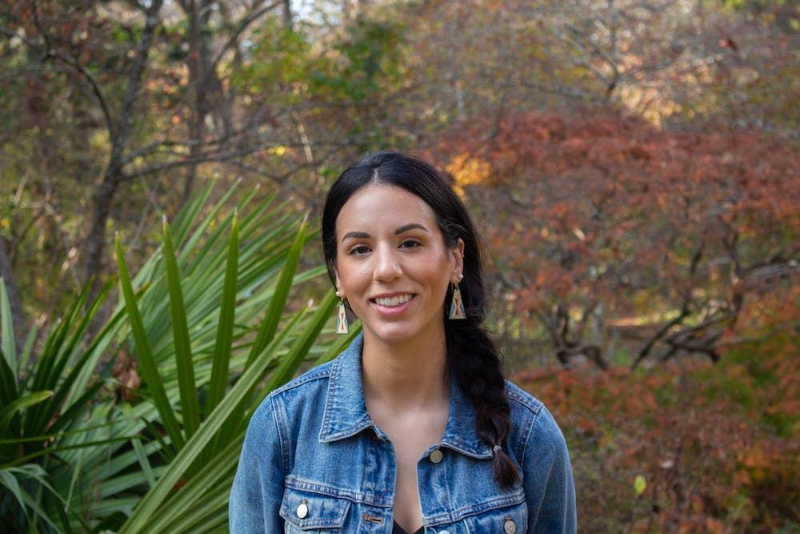
Buy PhotosPhoto by Alison Grau | The Daily Tar HeelMarissa Carmi, president of the First Nations Grad Circle, poses in the Coker Arboretum in Chapel Hill, N.C. on Monday, Nov. 7, 2022. The First Nations Graduate Circle provides mentoring and advocacy for American Indians aross campus.
By Stella Griffin

November 14, 2022 | 1:52am EST

Throughout November, campus organizations are celebrating American Indian Heritage Month.
Marissa Carmi is a citizen of the Oneida Nation of Wisconsin and co-president of the First Nations Graduate Circle, one of multiple indigenous groups at UNC. Recognition of the month, she said, is an opportunity for people in the community to join in on events.
“Native people, we’re celebrating and reflecting on our history all year long," she said. "We are here even beyond heritage month.”
On Tuesday, Nov. 15, the Carolina Indian Circle will host their annual Culture Show in the Student Union’s Great Hall.
“We celebrate being Indigenous people every day, but the month of November gives us an opportunity to celebrate with others,” Zianne Richardson, president of the CIC and a member of the Haliwa Saponi Tribe, said.
Ambassadors from tribes across North Carolina are invited to attend the event, which will feature traditional dishes from native tribes, as well as singing, dancing and a fashion show, Richardson said.
“We’ve worked really hard on it this year,” Dalton Locklear, vice president of the CIC and a member of the Lumbee Tribe of North Carolina, said. “We've had a couple of ups and downs, but I’m just really excited to see everyone in fellowship with the indigenous community here.”
There are many factors that go into planning events throughout the month, Locklear said. The group prioritizes the safety and well-being of their members by ensuring they avoid harmful stereotypes of indigenous people through their events.
“We also want to make sure that our performers are being compensated for what they're doing and make sure that they know they are appreciated for sharing their culture with the campus community, '' Locklear said.
The group also aims to promote tribal diversity through their events by emphasizing the visibility of both small and large tribes in North Carolina.
The FNGC will be hosting several events throughout the month, but Carmi said they are particularly excited for an event called “Native Audio with Mike Trombley.” It will feature Trombley, who is a musician and engineer as well as the founder and CEO of NativeAudio.
Trombley is a member of the Blackfeet Nation and will speak about the "business and culture of guitar pedal design.”
The event is sponsored by UNC’s American Indian & Indigenous Studies program and will be held at 12 p.m. on Monday, Nov. 14 at the Graduate Student Center.
“I think oftentimes, people don't expect to see native engineers, and they don't expect to see native musicians who are designing guitar pedals,” Carmi said.
She said the event is an opportunity to show the diversity of skills held by indigenous people, especially considering that North Carolina has one of the largest populations of native people east of the Mississippi.
“I know there's something different to celebrate every month, and I know that a lot of things happen throughout the year and there's so many different peoples who have been pushed aside and not recognized over the course of time,” Richardson said. “But I would encourage not just for Native American Heritage Month but for any month that celebrates a marginalized people, try to find ways to celebrate them throughout the year.”
Above all, Carmi said the greatest way to spread awareness is forging connections with people.
To become involved with the CIC outside of the celebratory events of the month, individuals can attend the group’s weekly meetings, follow @cic_unc on Instagram or reach out to Locklear or Richardson for more information.
“We try our best to make sure you’re included, you’re appreciated and your thirst for indigenous culture can continue,” Locklear said.
@dailytarheel
university@dailytarheel.com

